Change Order Request

March 8, 2016

Chinn Construction, LLC
14715 NE 95th Street, Suite 101
Redmond, WA 98052
Attn: Charlie Poggemann

Re: Hadley Apartment Project – Change Order Request

Charlie,

Due to RFI-245, we are having to re-align our boiler flues in the east-west direction as they exit the exhaust tunnel, and cap the un-used penetrations that were aligned in the north-south direction. Total costs for coordination, layout, core-drilling, grouting, and capping un-used penetrations is $1,470 + 10% OH&P = $1,617. Please let me know if you have any questions or comments. Thank you.

Sincerely,
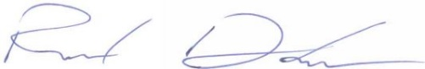
Richard Donelson
Project Manager / Estimator
LEED® Green Associate
richd@owpllc.net
425-591-4296 cell

